Import New Service Prices

# Overview

This is the process to bulk import new Telus prices when a new agreement is reached. We expect this process will be done every 5 years or whenever a new contract is decided on. This process will not update existing future price records in the system, it will only add new ones.

# Instructions

1. **Flip to main Dynamics CRM app (“Dynamics 365 – custom”)**
   1. Click the down arrow beside Ministry of Education
   2. Select “Dynamics 365 – custom

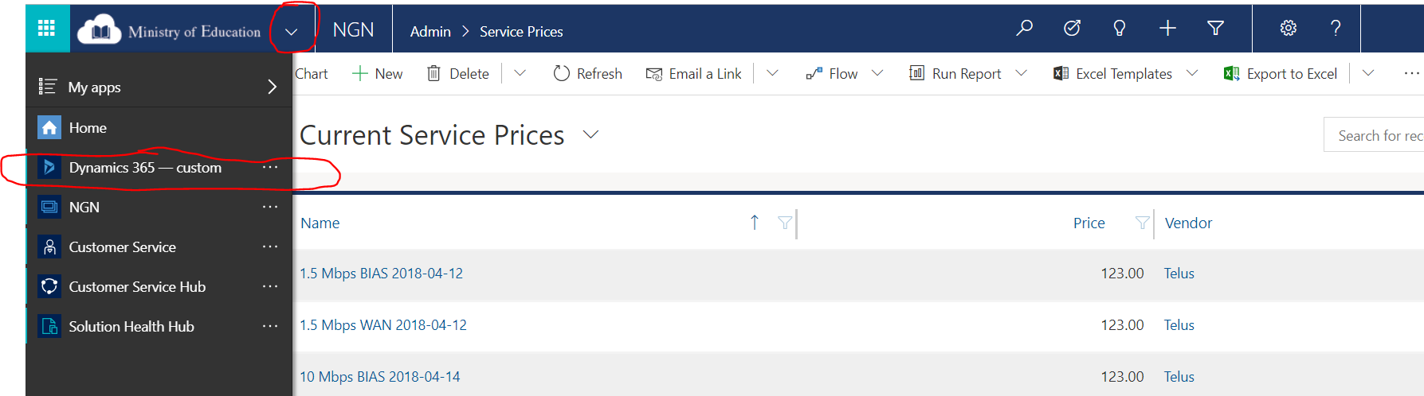

1. **Go to Data Management section**
   1. Select Settings
   2. Select Data Management

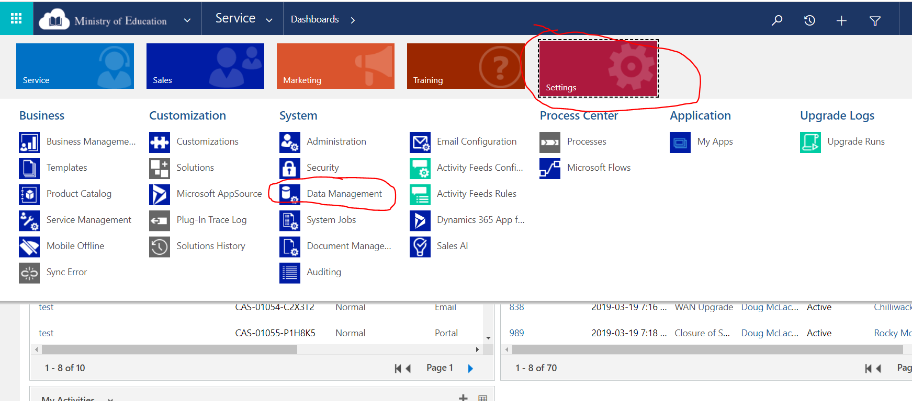

1. **Get a template for Service Price**
   1. Select “Templates for Data Import” 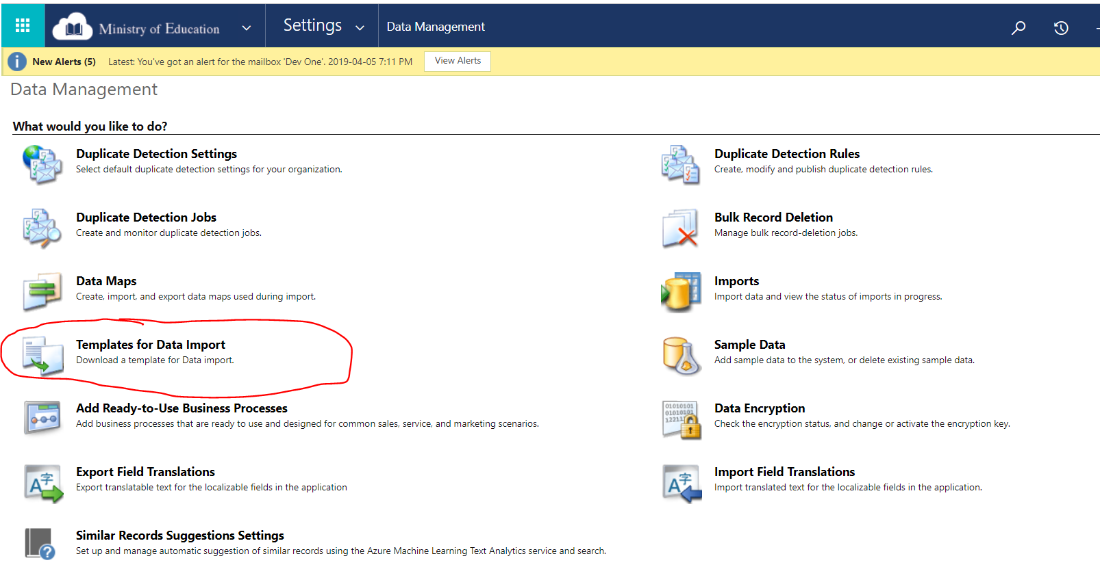
   2. Select “Service Price”
      1. 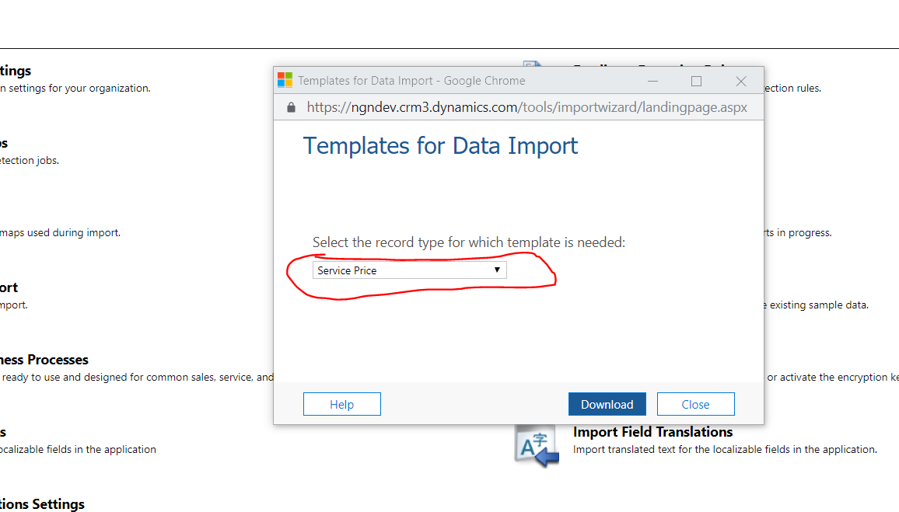
   3. Click Download
2. **Fill in the excel document**
   1. Enable Editing if needed (yellow box on top of excel document)
   2. Enter the “Service” (needs to match service names in CRM, aka 50 Mbps WAN, etc)
   3. Enter the “Vendor” (this will be Telus)
   4. Enter the new “Price”
   5. Enter the “Effective Date” (I recommend the format yyyy-mm-dd to prevent confusion)
   6. Leave Name and Owner blank
   7. Save the file
3. **Import the File**
   1. Select Imports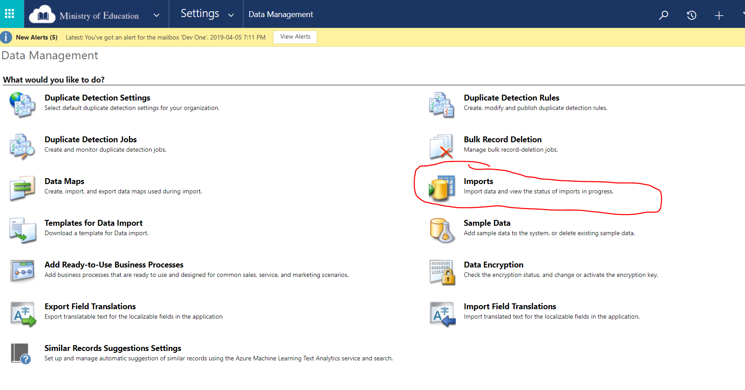
   2. Click Import Data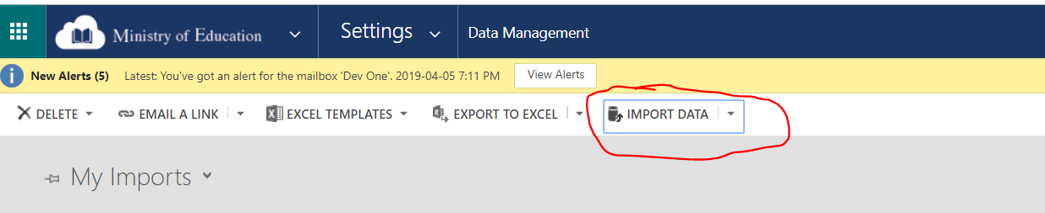
   3. Select your file and click Next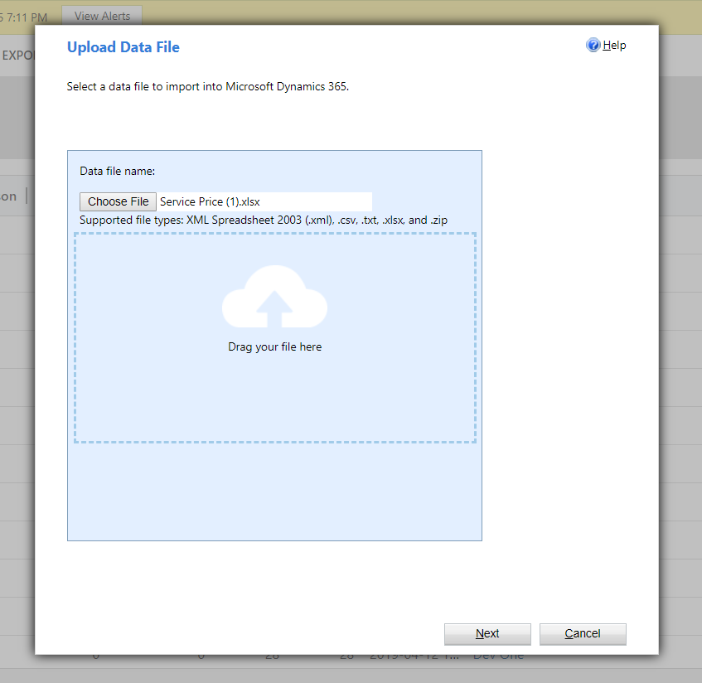
   4. Click Submit
   5. Click Finish
4. **Check if Import Worked**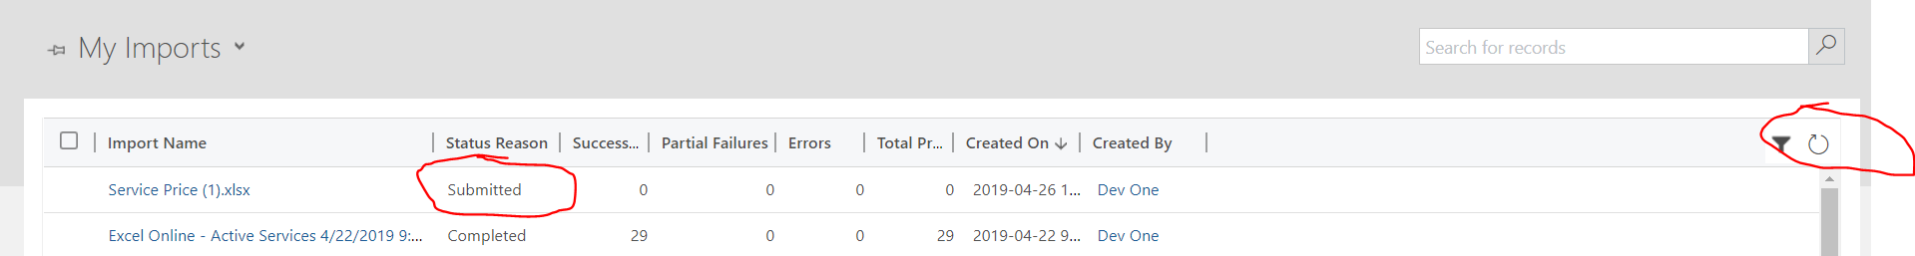
   1. Your import will be displayed under My Imports with a status of Submitted. It will take a few minutes to complete.
   2. Click the refresh button to see the updated status.
   3. If the Import failed, double click on the record to find out why

# Troubleshooting

1. Follow step #6 to check if the import worked.
2. Then double click on the import record and select either “Failed” or “Service Prices Partially Imported” on the left side of the screen.

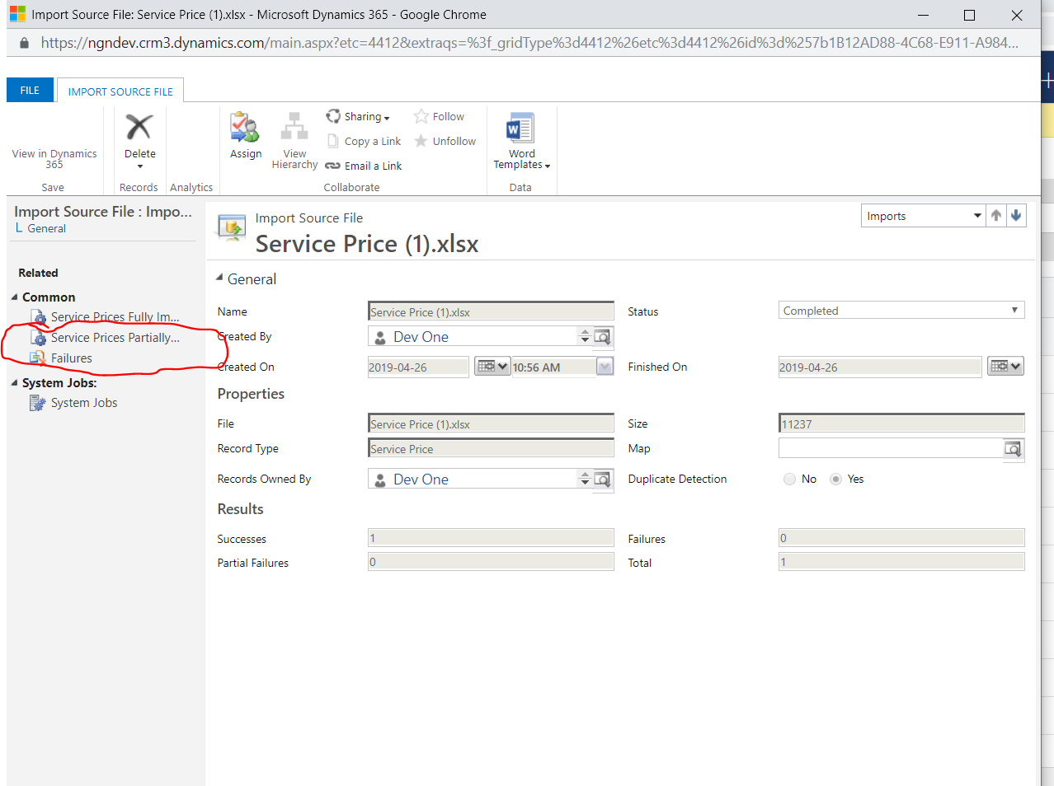

1. For Failed records
   1. Most likely you will see a message saying “The lookup reference couldn’t be resolved” and a Column Heading of either Service or Company. This means it couldn’t find a matching Service or Company record.
   2. Double check your spelling and create a new import file with only these failed records.
2. For Partially Imported records
   1. Review what the error is
   2. Manually update the record